9th A2 2025

Keep it real A2 Students book Ed. Richmond.

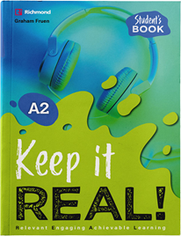

- FernándeS, Joaquín
- Ferreira, Angelina
- Ferreira, Leandro
- Pérez, Alfonso (*)
- Pérez, Catalina
- Raviola, Felipe
- Ripoll, Martina
- Silva, Franco (*)
- Van Rompaey, Ema

